# SUBQUERIES

The objective of this task was to get familiar with Subqueries.

I used Flights data from Mode to do this task.

The Flight Dataset contained the following columns:

|  |  |
| --- | --- |
| Field name | Data type |
| actual_arrival_time | Float |
| actual_flight_time | Float |
| acutal_departure_time | Float |
| air_time | Float |
| air_traffic_delay | Float |
| airline_code | String |
| airline_name | String |
| arrival_delay | Float |
| cancellation_reason | String |
| carrier_delay | Float |
| day | Timestamp |
| day_of_week | String |
| departure_delay | Float |
| destination_airport | String |
| destination_city | String |
| destination_state | String |
| distance | Float |
| flight_number | Float |
| late_aircraft_delay | Float |
| origin_airport | String |
| origin_city | String |
| origin_state | String |
| schedued_arrival_time | Float |
| scheduled_departure_time | Float |
| scheduled_flight_time | Float |
| security_delay | Float |
| was_cancelled | Boolean |
| weather_delay | Float |
| wheels_off_time | Float |
| wheels_on_time | Float |

I figured out the following questions using Subqueries from this data:

1. Flight with maximum arrival delay

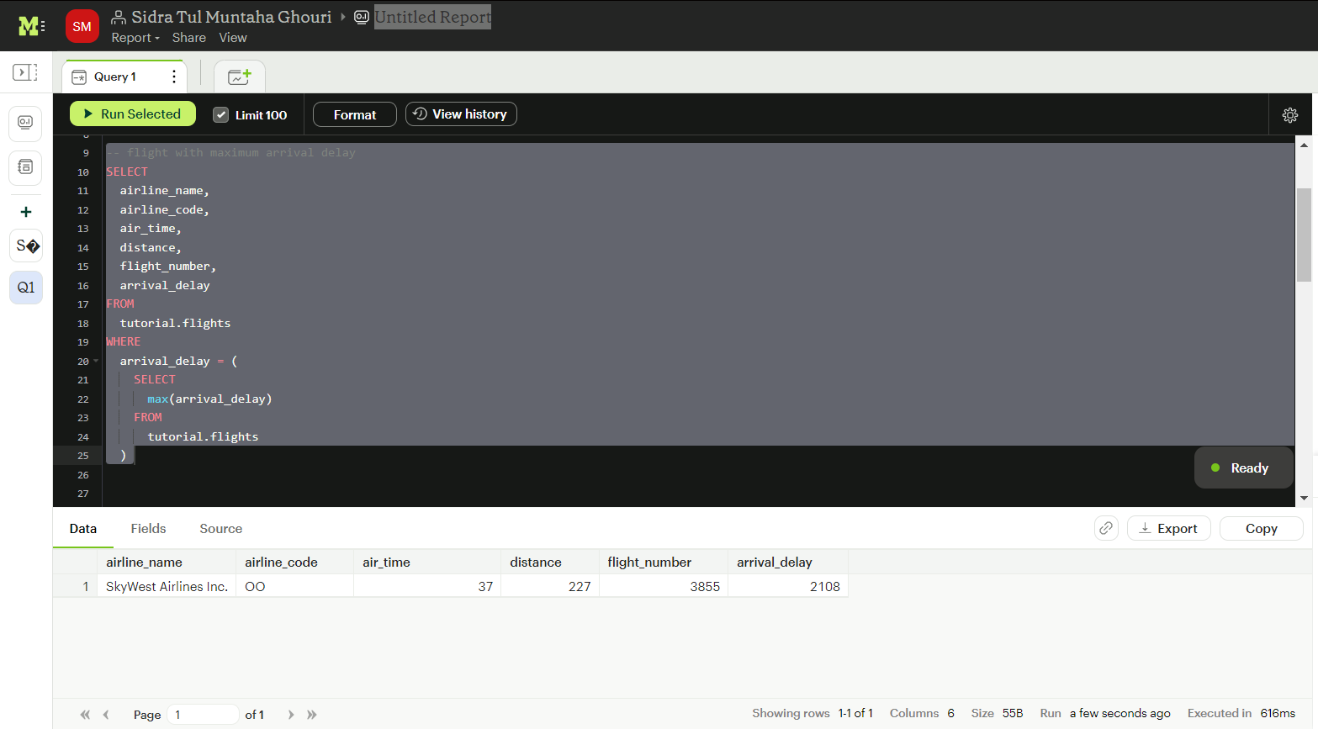

1. Airlines with departure delays wheren each airline's departure delay is Above Average Departure Delay:

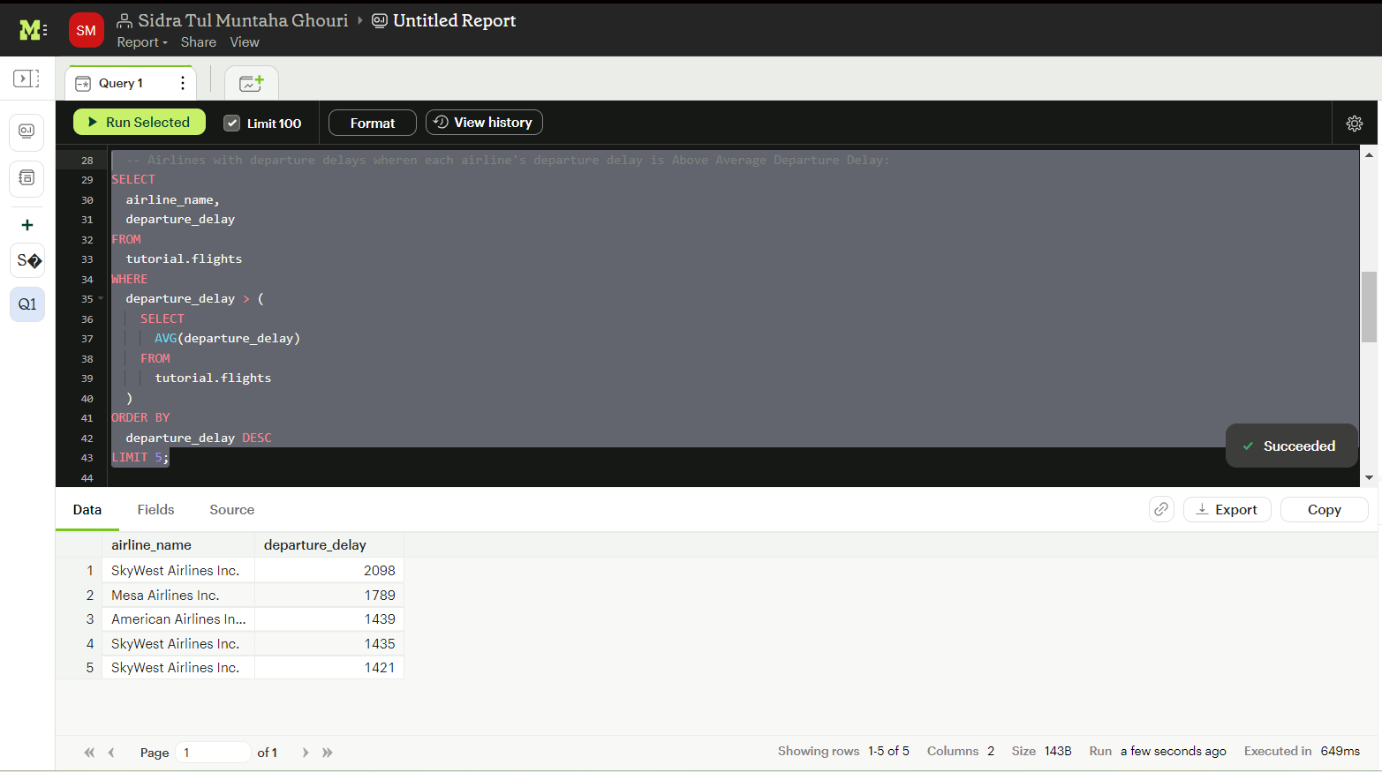

1. Airlines with above average departure delay

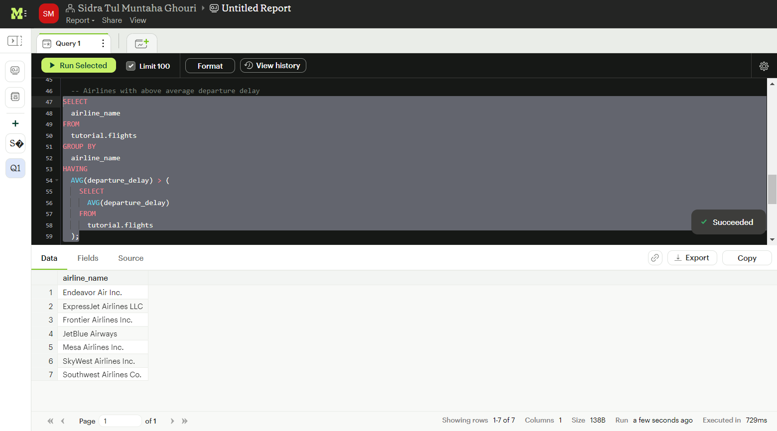

1. How many flights to Atlanta were cancelled on Friday.

